Normalization
- Normalization is the process of organizing the data in the database.
- Normalization is used to minimize the redundancy from a relation or set of relations. It is also used to eliminate undesirable characteristics like Insertion, Update, and Deletion Anomalies.
- Normalization divides the larger table into smaller and links them using relationships.
- The normal form is used to reduce redundancy from the database table.
Why do we need Normalization?
The main reason for normalizing the relations is removing these anomalies. Failure to eliminate anomalies leads to data redundancy and can cause data integrity and other problems as the database grows. Normalization consists of a series of guidelines that helps to guide you in creating a good database structure.
Data modification anomalies can be categorized into three types:
- Insertion Anomaly: Insertion Anomaly refers to when one cannot insert a new tuple into a relationship due to lack of data.
- Deletion Anomaly: The delete anomaly refers to the situation where the deletion of data results in the unintended loss of some other important data.
- Updatation Anomaly: The update anomaly is when an update of a single data value requires multiple rows of data to be updated.

Types of Normal Forms:
Normalization works through a series of stages called Normal forms. The normal forms apply to individual relations. The relation is said to be in particular normal form if it satisfies constraints.
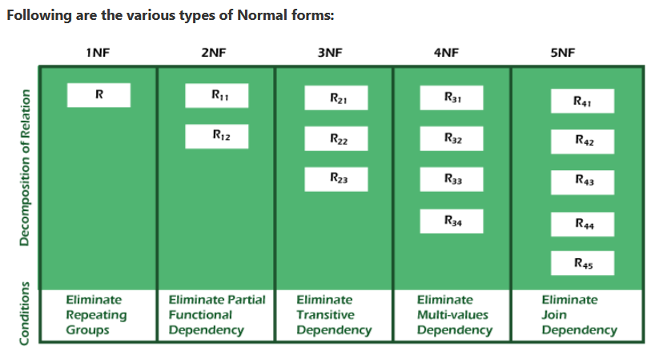
Normal Form | Description
1NF | A relation is in 1NF if it contains an atomic value.
2NF | A relation will be in 2NF if it is in 1NF and all non-key attributes are fully functional dependent on the primary key.
3NF | A relation will be in 3NF if it is in 2NF and no transition dependency exists.
BCNF | A stronger definition of 3NF is known as Boyce Codd's normal form.
4NF | A relation will be in 4NF if it is in Boyce Codd's normal form and has no multi-valued dependency.
5NF | A relation is in 5NF. If it is in 4NF and does not contain any join dependency, joining should be lossless.

Advantages of Normalization
- Normalization helps to minimize data redundancy.
- Greater overall database organization.
- Data consistency within the database.
- Much more flexible database design.
- Enforces the concept of relational integrity.

Disadvantages of Normalization
- You cannot start building the database before knowing what the user needs.
- The performance degrades when normalizing the relations to higher normal forms, i.e., 4NF, 5NF.
- It is very time-consuming and difficult to normalize relations of a higher degree.
- Careless decomposition may lead to a bad database design, leading to serious problems.

First Normal Form (1NF)
- A relation will be 1NF if it contains an atomic value.
- It states that an attribute of a table cannot hold multiple values. It must hold only single-valued attribute.
- First normal form disallows the multi-valued attribute, composite attribute, and their combinations.
Example: Relation EMPLOYEE is not in 1NF because of multi-valued attribute EMP_PHONE.
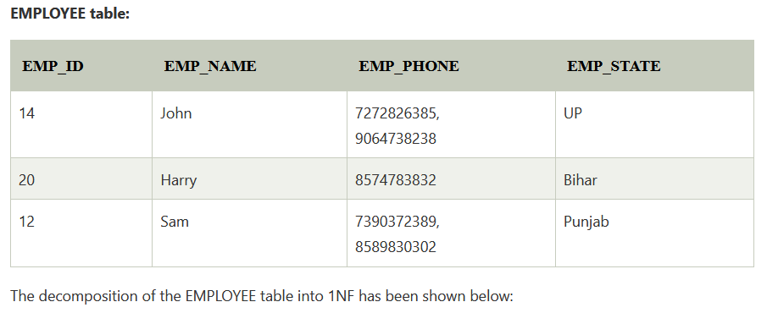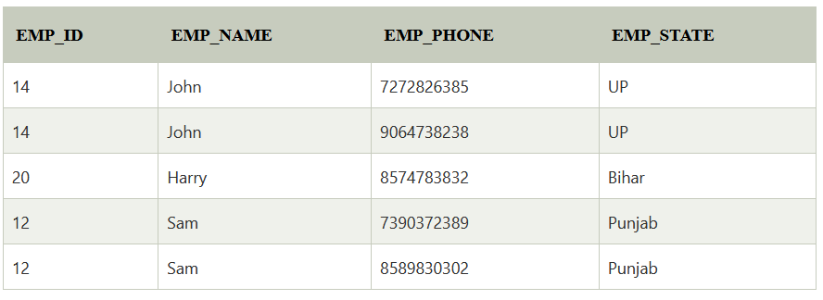

Second Normal Form (2NF)
- In the 2NF, relational must be in 1NF.
- In the second normal form, all non-key attributes are fully functional dependent on the primary key
Example: Let's assume, a school can store the data of teachers and the subjects they teach. In a school, a teacher can teach more than one subject.
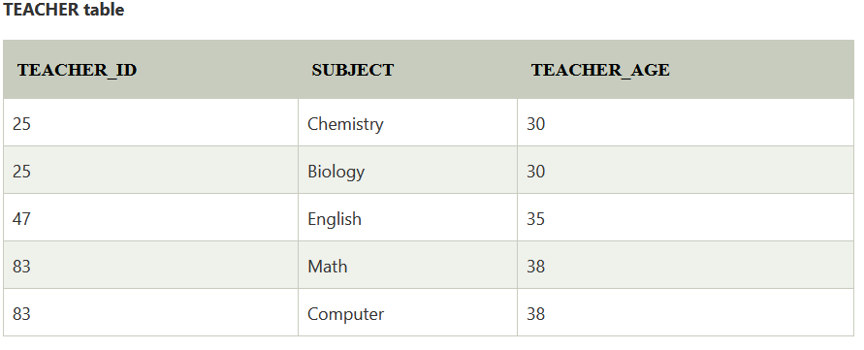 In the given table, non-prime attribute TEACHER_AGE is dependent on TEACHER_ID which is a proper subset of a candidate key. That's why it violates the rule for 2NF.
To convert the given table into 2NF, we decompose it into two tables:
